Mathew Barber 2021



Lorem ipsum dolor sit amet, consectetur adipiscing elit, sed do eiusmod tempor incididunt ut labore et dolore magna aliqua. Ut enim ad minim veniam, quis nostrud exercitation ullamco laboris nisi ut aliquip ex ea

Research Report

**Remote working** – The option to work remotely was already being embraced by some businesses in the pre-pandemic era. These businesses were making some progress to adapt their working practices to accommodate this process. However, there had been a reluctance to have staff working remotely and this has largely centred around productivity concerns, security implications and technology issues.

# Abstract

This research paper is about communication with the health care environment and how it has been affected with the current pandemic restrictions, mainly concentrating the research on palliative and end of life care. We asked many different questions within the paper, but all based around the hypnosis of - Can sensory virtual reality improve communication within the health care environment, due to the changes that had to be made from the Covid-19 outbreak, in face-to-face contact?

By using primary and secondary research of questionnaires, interviews, emails, and information published of hospital and government websites, we were able to discover that the technology does exist or is in the prototype stage like the avatars. We also found medical professionals liked the idea and believed it would be an improvement on the current iPad use, they also stated it might be useful in other areas including mental health.

In summary, the simple act of human interaction can never be replaced by technology, but there must be a place between face-to-face and the cold feeling of a video chat on and iPad or phone. As humans in times of pain and hardship we need the comfort and support that a simple reassuring touch can give.

As you can see from all the data gathered through interviews and questionnaires from medical staff and data requests form the NHS and government departments, a Sensory Virtual Reality System would over all be positively received by the medical professionals who would be using it, even specifying particular areas they believe it would a real asset.

Contents

Abstract 1

Subject – Remote Working 4

Theme – Health Care 4

Context – Communication 4

Topic – Sensory Virtual Reality (SVR) 4

Hypothesis 4

Action Plan 5

Remote working Palliative care/end-of-life care 6

Justification 6

Current Situation 6

Virtual Reality within the NHS 7

Literature Review 8

Sensory Virtual Reality System 9

Questions to Be Asked 9

Limitations of the Study 10

Research Methods 10

Ontology 11

Epistemology 11

Positivism: 11

Interpretivism: 11

Methodology 11

Methods 12

Qualitative and Quantitative Research 12

Qualitative 12

Quantitative 12

Methods and Methodologies Used 13

Primary Research 13

Questionnaire 13

Interview 13

Past Research Papers 13

Secondary Research 13

Website 13

Government/Hospital Trusts 13

Results 14

Interviews 14

Questionnaire 16

Data from Direct from Government and Hospitals 20

Time/Breakdown Schedule 22

Ethics 23

Sensory Virtual Reality System Technology 24

Headset 25

Smell 25

Touch – Glove 25

Realistic Avatars 25

Cost 26

Future Innovations 28

Critical Evaluation 30

Record of Sources and References 32

Books 32

Journals, Research Papers and PDF’s 32

Website & others 33

Tutorial Meetings: 34

Bibliography 40

# Subject – Remote Working

The option to work remotely was already being embraced by some businesses in the pre-pandemic era. These businesses were making some progress to adapt their working practices to accommodate remote working by allowing those in certain job roles to take the opportunity to work from home, albeit a day or two a week. However, overall, there had been a reluctance to have staff working remotely and this has centred around productivity concerns, security implications and technology issues.

# Theme – Health Care

One of the hardest areas to have remote work is within the health care profession. This is due to needing to go into the hospitals or doctors for things like X-rays, dialysis, and blood work, as well as for diagnoses that require a more hands-on human approach. The security of patient health data transmitted electronically is also a real concern. Yet there has been some area in which remote working has been introduced during Covid-19 to ease the risk of infection to patients and health care professionals alike.

# Context – Communication

The main area remote work has been within communication. Whether it be through video chats with your GP or nurses needing to facilitate Skype calls for patients nearing the end of their life, due to visitor restrictions as a response to Covid-19 and since this is extremely important to the mental stability and mental health of a patient it has become a part of the nurse’s role.

# Topic – Sensory Virtual Reality (SVR)

This research is to decide if there is an interactive solution where we can bring all the people involved together and immerse them in VR (Virtual Reality) which could be the closest thing to human interaction that can be done in certain situations and if it would be ethical to use this technology within the health care profession.

# Hypothesis

Can sensory virtual reality improve communication within the health care environment, due to the changes that had to be made from the Covid-19 outbreak, in face-to-face contact?

# Action Plan

|  |  |  |  |
| --- | --- | --- | --- |
| **ACTION** | **COMPLETE (Y/N)** | **DATE** | **TUTOR SIGNED** |
| Research remote working | Yes | 12/10/2021 |  |
| Research and choose theme | Yes | 26/10/2021 |  |
| Context within theme | Yes | 28/10/2021 |  |
| Choose topic | Yes | 28/10/2021 |  |
| Hypothesis | Yes | 29/10/2021 |  |
| Action Plan/Gantt chart | Yes | 02/11/2021 |  |
| Basic research on methodologies | Yes | 05/11/2021 |  |
| Start Proposal | Yes | 09/11/2021 |  |
| Palliative care/end-of-life care | Yes | 10/11/2021 |  |
| Current Situation | Yes | 17/11/2021 |  |
| Email NHS | Yes | 22/11/2021 |  |
| Reply From NHS | Yes | 22/11/2021 |  |
| Virtual Reality in NHS | Yes | 23/11/2021 |  |
| Research reports | Yes | 29/11/2021 |  |
| Sensory Virtual Reality Tech | Yes | 02/12/2021 |  |
| What questions can/need to be asked | Yes | 13/12/2021 |  |
| what factors need to be considered | Yes | 14/12/2021 |  |
| Write up proposal Report and PowerPoint | Yes | 15/12/2021 |  |
| Present PowerPoint to sponsors | Yes | 17/12/2021 |  |
| Start Research Report Paper | Yes | 04/01/2022 |  |
| Justification | Yes | 04/01/2022 |  |
| Literature Review | Yes | 10/01/2022 |  |
| Limitations of the Study | Yes | 17/01/2022 |  |
| Research Methods | Yes | 18/01/2022 |  |
| Qualitative and Quantitative Research | Yes | 03/02/2022 |  |
| Primary and Secondary Research | Yes | 04/02/2022 |  |
| Send Out Questionnaires | Yes | 21/02/2022 |  |
| Interviews with NHS Staff | Yes | 21/02/2022 |  |
| Interviews with NHS Staff | Yes | 21/02/2022 |  |
| Compile Questionnaire Reply’s | Yes | 21/03/2022 |  |
| Write Up Results | Yes | 22/03/2022 |  |
| Make Graphs in Excel | Yes | 28/03/2022 |  |
| Summary of Results | Yes | 30/03/2022 |  |
| Compile Data Collected from Government | Yes | 05/04/2022 |  |
| Compile Data Collected Direct from NHS | Yes | 06/04/2022 |  |
| Ethics | Yes | 07/04/2022 |  |
| Sensory Virtual Reality System Technology | Yes | 11/04/2022 |  |
| Cost | Yes | 02/05/2022 |  |
| Future Innovations | Yes | 05/05/2022 |  |
| Critical Evaluation | Yes | 12/05/2022 |  |
| Prepare PowerPoint of Report Conclusion | Yes | 24/05/2022 |  |
| Present PowerPoint | Yes | 06/06/2022 |  |
|  |  |  |  |
|  |  |  |  |
|  |  |  |  |
|  |  |  |  |

# Remote working Palliative care/end-of-life care

In this paper I will be mainly looking at how the sensory VR can work within the Palliative care and end-of-life care are, but this is not the only area of care that could benefit from this, other areas of care are:

* Doctors communicating with patients especially for diagnosis when it can’t be in person.
* Mental Health appointments
* Doctors and Nurses when speaking and/or consoling family members

There will be more medical professionals who will see other uses for this which will benefit them and their patients.

One of the hardest jobs is palliative and end of life care there is no real remote working possible as it is a hands-on job, there are thing in place like the remote heart and posture monitors. But can more be done to help the doctors, nurses, and health care workers?

# Justification

Remote work is defined as work that's done outside of a physical office. It's also known as working from home or telecommuting. The point of remote work is that people can achieve all their usual, daily tasks, without needing to commute to an office each day.

As a nurse or other medical professional, it’s safe to say that when working in a hospital their job cannot be remote, but there is a word in the definition telecommunicating. Dure in covid we saw nurses having to use this more than at any other time for patients to communicate with family and since this is extremely important to the mental stability and mental health of a patient it becomes part of the nurse’s role to facilitate it.

“Palliative care nurses provide an integrative and multidisciplinary treatment approach that helps patients maintain physical, mental, and emotional health.” (C-Care, 2017)

Most importantly, palliative care nurses help patients, and their families feel safe and comfortable.

With that comes the ability to communicate with one another in the best way possible.

# Current Situation

The current situation for this topic needs to be explained in two parts, firstly being the current situation surrounding Covid -19 and the restrictions and pressures it has put on to the health care system. As of the Monday 23rd of March 2020 the government announce there would be no visitor in hospitals in the whole of the UK, they stated the only exceptions to this rule would be, one birthing partner, one visitor per child patient, one visitor for patients with dementia, one visitor for end-of-life patients. Most of these exceptions were stopped at the pandemic got worse. As of the date of this research paper Covid-19 is an ongoing problem, even though most people have returned to working in their offices and people have returned to the normal school routines, hospitals still have selected Covid wards and unfortunately people are still dying from this illness, therefor most hospitals have some form if not complete visitor restrictions in place. This has created one of the biggest none life threating problems that has risen due to covid-19, families not being able to communicate and even say their final farewells to dying relatives, and the absence of the important supporting role from family for patients who had dementia, learning disability, mental health problems and end of life care needs was identified as a real challenge. Also, family members unable to visit could find the situation stressful, and keen to understand how the visiting limitations were being applied and the reasons behind them. STSFT (South Tyneside and Sunderland NHS Foundation Trust) created several initiatives alongside the NHS and the other trusts nationwide to provide support to patients, families, and clinical teams: virtual visiting using hospital iPads so patients could see and speak to their families via video calling and supporting outgoing phone calls to families through the bedside TV provision, but one of the biggest problems is that the patient and the families felt disconnected from each other. Now I’m not stating that there is an easy solution in this situation because what needs to be stated here is nothing will ever replace human contact in these situations when such emotions and heartache are at the forefront.

## Virtual Reality within the NHS

There are five main areas in which virtual reality is being utilised within the NHS currently. **Training surgeons** - VR now allows more than just watching an operation take place from the point of view of the surgeon. The technology is now being used to train aspiring surgeons and for surgeons to practice operations. Dr. Shafi Ahmed performed the first VR surgery in 2016 which could be viewed by anyone online in real time. Virtual reality solutions to train surgeons have been proven to be better than traditional training methods, a recent study from Harvard Business Review showed that *VR-trained surgeons had a 230% boost in their overall performance compared to their traditionally trained counterparts.* (Blumstein, 2019)

**Relaxing patients with Medical VR** - patients awaiting surgery at St George’s Hospital in London were given the option to use a VR headset prior to and during their operation, viewing calming landscapes during the procedure. 100% of the patients stated that their overall hospital experience was improved due to the VR, while 94% stated they were more relaxed. 80% answered that they were in less pain after the VR experience and 73% reported feeling less anxious.

**Real conferences with virtual reality for an enhanced experience** - Visualize the presenter and their audience with VR headsets, the interactive possibilities that VR offers like 3D visualization and gamification, audience engagement and the overall quality of the conference would increase rapidly.

**Helping doctors with empathy** - physicians are using the VR experience to see what life is like for the elderly. Experiencing these conditions can help medical students and young physicians develop one of the most important abilities to becoming a doctor: empathy.

**Speeding up recovery in physical therapy** -for patients who survived a stroke or traumatic brain injury, the sooner they can start rehabilitation, the better chances they have for effectively regaining lost functions. Bringing a gamified approach to physical therapy by using VR for such patients with the aim is to make physical therapy more fun to increase patient engagement.

I did however find another way in which VR is being used in some hospitals, I sent a freedom of information act request to my local hospital Warrington and Halton Trust. I asked, do they use VR? If so in what areas? And lastly what type of VR they use?

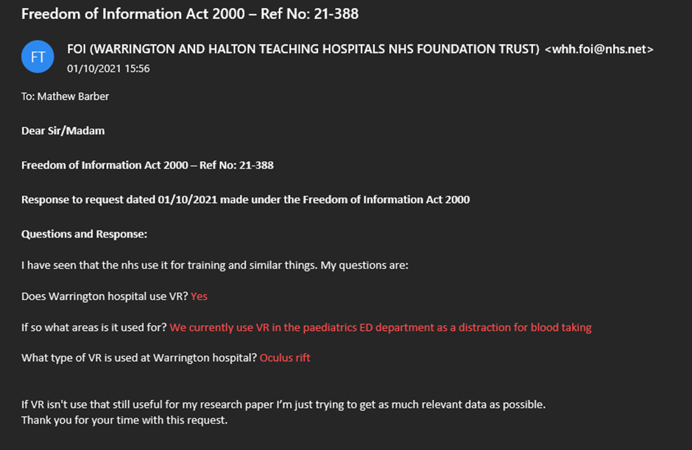

As you can see from the screenshot above, I did receive a response to my email. But I was shocked that they did have this technology available, yet only use it in one single area. This might not seem too bad at first but when you take in to account Warrington and Halton Hospitals are training hospitals for doctors and nurses across the northwest you would hope they would be getting the best training and equipment available.

# Literature Review

There have been many reviews and studies on how virtual reality is used in hospitals such as, *Giuliana Guazzaroni – Virtual and Augmented Reality in Mental Health Treatment – 2018 - Publisher: IGI Global, Clive Langman - Introduction to Vocational Rehabilitation Policies, Practices and Skills – 2012 - Publisher: Taylor & Francis,* there has even been papers directly linking it to the NHS, *Nick Peres - Head of Technologies R+D PhD Transtechnology Researcher - Virtual Reality in healthcare and potential application to NHS library services* and an article in Human Movement with seven authors but only four are named*, Justyna Mazurek, Paweł Kiper, Błażej Cieślik, Sebastian Rutkowski - Virtual Reality In Medicine: A Brief Overview And Future Research Directions – 2019.*

There have also been studies, books, and research into communication with virtual reality, *Frank Biocca - Communication in the Age of Virtual Reality – 2013 - Publisher: Taylor & Francis, Editors: Halimah Badioze Zaman, Ingela Nyström, Maria Petrou, Patrick Olivier, Peter Robinson, Sergio Velastin, Timothy K. Shih - Visual Informatics: Sustaining Research and Innovations – 2011 - Publisher: Springer.*

Unfortunately, there have been no direct review, report or research done on virtual reality and communication within the health care service that I was able to find. Some of the papers I have found do have useful information in them but mostly on how limited people views are on today’s technology.

# Sensory Virtual Reality System

When discussing a sensory virtual reality system as a communication device we need to break it down it to its main parts the virtual reality system and what is meant by sensory.

Virtual Reality is the use of technology to create a computer-generated environment. VR places the user inside of the computer-generated environment, which is different to traditional user interfaces. Instead of viewing from the screen in front of them, users are immersed and able to interact with 3D settings. Virtual Reality’s most immediately recognizable hardware is the head-mounted display also referred to as goggles. Human beings are highly visual creatures, and display technology is often the biggest difference between an immersive Virtual Reality system experience and traditional user interfaces.

When we talk about the sensory section what we are really saying is how lifelike can we make something not just visually but by including some of the other human senses like sound, smell and even touch. By simulating these senses where possible, the computer is transformed into an artificial world which can feel as real as possible. The only limits to Sensory VR experiences are computing power and the availability and willingness of companies to make these systems multi-functional and not just for gaming.

# Questions to Be Asked

The use of a sensory virtual reality device brings up many questions that need to be asked and answered before any such system could be tested for purpose. Some of the question that need to be aske are

* How are patients currently contacting family and friends?

• Cost – not only the cost for the unit for the patient but also the cost to the families

• The technology – the tech is already out there for gaming and military uses but not for medical in this way (why?)

• Ethics

* Should it be used at all in the NHS?
* Should it be used to give diagnosis or test results?
* When should it be used?
* If a patient is using it will there be safeguarding?
* Will there be data collection?
  + - What data?
    - Who will have access to the collected data?

My aim is to answer these questions throughout this report within the limitations I mention in the next section. There are question I know can’t be answered within this paper such as:

• The set up – the set up would have to be simple enough for elderly and sick people to easily use.

• Weight – units would need to be light weight yet completely immersive.

• Internet connection – the speed and access to the internet for use would have to cover all area

• Timing – who decides when it can be used?

• Who – who decides which patients need to use it?

As these question and others would require a larger research project with access to much more data and help from tech companies who can design and build this type of system.

# Limitations of the Study

Due to the restrictions enforced from Covid-19 attending hospitals to visit with the doctors and nurses face-to-face and explain what the research paper is for and why id like the to fill a questionnaire as well as interviews because of this I will be asking them to do thing in there extremely limited free time away from work will add difficulties in getting as many participants as id like.

Also, with no access to patients due to the above reasons I will not be able to get feedback from them at all. I don’t believe it would be ethical or proper to approach families who have lost loves ones during the pandemic, through Covid or not, to discuss the ways in which they were able to communicate.

The last limitation to this study is no funding or sponsorship any and all research that requires cost would have to come from my own pocket limiting its rage dramatically. It also means that there is no influence to have participation from the doctors, nurses or even hospitals when trying to gather facts and figures on patients during the Covid-19 pandemic compered too before.

# Research Methods

(Brown, 2021)

## Ontology

Ontology concerns statements about the nature of being and existence. One of the longest standing ontological questions in philosophy concerns the existence, of a God or at least some sense of a higher deity. Questions of ontology are central to the questions asked in social research, to the concepts we use, and actions taken. For example, the positivist may ask cause and effect type questions ‘how does class background affect educational achievement?’ whilst the anti-positivist may change the question to ‘what different meanings have been attributed to concepts of class and achievement?’ Ontology therefore is at the top of the hierarchy under which follows epistemology, methodology.

## Epistemology

Epistemology is the theory of knowledge and how it is collected. In research terms your personal views and knowledge strongly influences your analysis of data and therefore your philosophical opinion should be made clear from the beginning. Knowledge can be either empirical or intuitive. Intuitive knowledge comes from beliefs and faith, empirical knowledge is connected to anything that can be impartially described and proven.

Within epistemology, there are several approaches and branches, two of which are positivism and interpretivism. These two philosophical approaches that are at the most extreme ends of a spectrum and by looking at the relationship between them can help show the impact this can have on your research.

### Positivism:

The basic principle of positivism is a scientific perspective on knowledge and the world. Data collection is undertaken based on statistics and several participants. When using a positivist approach this would mean that the research moves through a hypothesis and then theories and you look at the data objectively. Positivist research therefore is quantitative in nature.

### Interpretivism:

This branch of epistemology is in a way an answer to the objective world of positivism that the researchers wanted. The basic idea of the interpretivist approach is that the researcher is part of the research, interprets the data and can therefore never be completely objective and removed from research. Interpretivists are interested in specific, contextualized environments and recognize that reality and knowledge are not objective but influenced by people in this environment. This philosophical outlook is more subjective and subject to prejudices, so cannot be generalized in the way that positivist research can be.

## Methodology

The methodology is a research project's overarching design. This is to do with how the researcher collects and interprets knowledge. The methodology is the philosophical perspective of the researchers’ beliefs about life, learning and knowledge, and as such it is the lens through which the researcher will look at answering research questions. In a way this is a specific view and opinion that the researcher takes and a framework within which the researcher works. As such, this framework and philosophical outlook must be made clear and explained clearly. This section therefore takes stock and describes how you view knowledge.

## Methods

The methods are tools that allow researchers to collect data. Every method naturally has its advantages and limitations. Therefore, it is important to identify exactly what it is that you want to find out about in your research, as this will determine which methods are suitable and indeed best suited for your investigation. Also, the methods will be determined by selected methodology, in that some frameworks lend themselves more to specific data collection methods than others.

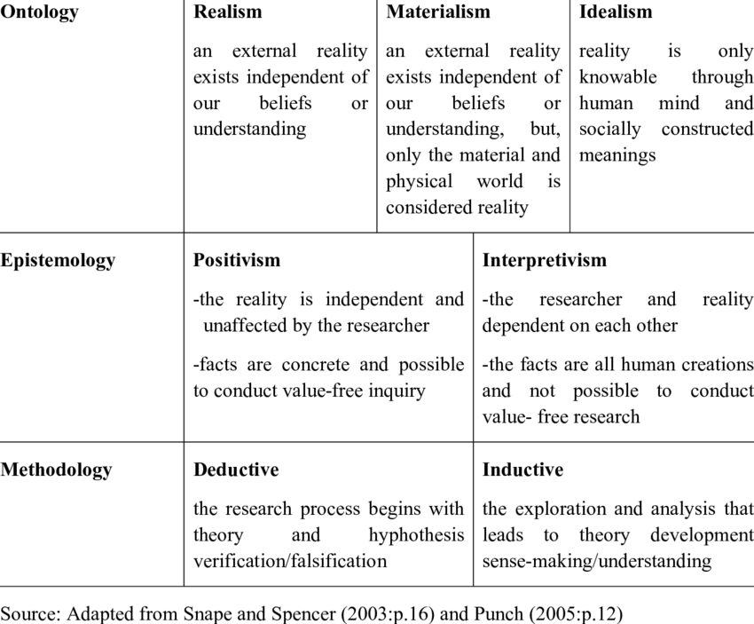

(Ibrahim, 2017)

## Qualitative and Quantitative Research

### Qualitative

Qualitative research is the method of collecting, analysing, and interpreting non-numeric data. Qualitative data is defined as non-numeric data, such as text, video, photos, or audio recordings. This type of data can be collected using diary accounts or in-depth interviews and analysed using grounded theory or thematic analysis. There are several types of qualitative research methods, including journal accounts, in-depth interviews, documents, focus groups, case studies and ethnography.

### Quantitative

Quantitative research involves the process of objectively collecting and analysing digital data to describe, predict, or control variables of interest. Quantitative research aims to test causal relationships among variables, predictions and generalize results to wider populations. Experiments usually produce quantitative data, as they are concerned with measuring things. However, other research methods, such as controlled notes and questionnaires, can produce quantitative information.

## Methods and Methodologies Used

Epistemology – Positivism - Positivist research therefore is quantitative in nature. based on statistics and several participants. (Questionnaire)

Epistemology - Interpretivism - the researcher is part of the research, interprets the data and can therefore never be completely objective. (Interviews)

Methodology – I believe that an iPad wasn’t sufficient for communication for patients during the pandemic and more could have been done. I not sure if SVR system is the answer but will remain open minded.

Qualitative – Is mainly my primary research below of non – numeric data.

Quantitative – Is my secondary research based on government and NHS facts and figures.

## Primary Research

### Questionnaire

A questionnaire can be made up and given to the doctors and nurses on the palliative and end of life wards at the local hospital asking them a few questions on if the proposed solution would be a benefit to patients.

### Interview

Interviewing any medical professional in this area about the current communication situation and if the proposed solution in viable will help shape the questions for the questionnaire.

### Past Research Papers

Any research papers than have been done on virtual reality use in hospitals.

## Secondary Research

### Website

Government Covid-19 website for facts and figures about the death totals and how the project could be funded.

To find if this is viable in the terms of technology, does it already exist?

### Government/Hospital Trusts

Contacting the government and/or hospital trusts directly via email or phone for details on Covid-19 and patient care that isn’t shared publicly on their websites.

# Results

## Interviews

I have been lucky enough to have two people agree to do an interview with me, a doctor, and a nurse. Both of these people work on the Covid wards in the height of the pandemic and will have a unique insight in to the communication situation during this time. I have agreed not to use their names or state in which hospital they worked so as not to limit their opinions on anything or to risk their jobs.

I had seven set questions to ask each of them and I also explained what Sensory Virtual Reality was and my proposal. Both people were interviewed on the same day, but the interview were conducted individually.

**Doctors interview**

*Q1. What was/is your experience of communication with patients and their families during Covid-19?*

Communication started off normally as with every other patient, but it took longer due to the hygiene rule brought in for Covid. After they stopped visitors entering the hospital communication became more difficult, we were advised to do video consultations with Covid positive patients and to continue with the new hygiene rules for in person consultations with patients on other wards if we had to work them. With visitors being stopped it meant a lot of families ringing as much as possible to get updates on their family member, which is perfectly understandable with how worried everyone was.

*Q2. Do you think the iPad was a good solution after the 23rd of March 2020 when visitation was stopped for communication?*

Simply, no. But it was the only solution we were offered, personally I don’t think remote consultations are a good idea in a hospital because at some point you will have to give life changing news to someone.

*Q3. Can you personally think of anything that would have been a better solution?*

Sticking with personal consultations for patients is the only better solution I can think of, but of course that has its own risk to patients and doctors and possibly even family member to both as well.

***At this point I explained my research paper into Sensory Virtual Reality, hardware, software and how I believe it could work.***

*Q4.**In your opinion and from your experiences do you believe the SVR would be a better option to the iPad?*

From what you explained to me, the touch aspect is a massive part, to have the feel of a loved one touch your hand, even if it is simulated, would be a massive step forward for patients and the mental state at times.

*Q5. What do you see as issues for bring the SVR into reality for use within the NHS?*

There are a couple of issues that I’d be worried over, firstly cost, how would it be funded, or even would anybody found something like this, especially if they don’t see the problems with the current system? Next would be most people of a certain age don’t like change, how would you get them to embrace this when many struggle to use Facebook out of fear of doing something wrong on it? Lastly, how would families get the system so they can speak to their family members in hospital, and again would they have to buy one, rent one?

*Q6. Do believe this technology will ever move from training purposes, to being used for communication between medical professionals and patients and/or families?*

Possibly one day, but I think this SVR is a head of its time for the NHS, they would have to see it out there being used by other companies before they would go down that road. But we do already use VR so maybe I’m wrong and they will decide to be the one who push for it or find a different solution to the communication problems.

*Q7. Would you like to add anything, that you think is relevant?*

The thing I worry about with these systems is, will we lose the humanity of situation by everyone being remote, I know you have tried to solve this with the glove so it feels like touch, but what about that patient who lives alone and you’re telling them they have cancer a touch of the hand isn’t enough, that person needs comforting, consoling with a hug they need someone to just sit there in silence while the process what’s been said. I don’t believe any remote system can be fully embraced until it can do everything I can and need to do in person.

**Nurses Interview**

*Q1. What was/is your experience of communication with patients and their families during Covid-19?*

Communication for me was organising when patients could use the iPads to see and speak with their loved ones. It was a complicated process as you would have to phone the families to arrange a time when they could be online to do these video chats.

*Q2. Do you think the iPad was a good solution after the 23rd of March 2020 when visitation was stopped for communication?*

We didn’t have anything else and with visitors not being allowed into the hospital, but we had to use something for the patient’s mental health. The biggest problem I found was that the iPads only had Skype on them, and we weren’t allowed to put other applications on, so if the family or loved ones didn’t have Skype or didn’t know how to use it nurses were using their personal phone to ensure they could still see and speak to each other.

*Q3. Can you personally think of anything that would have been a better solution?*

The only other way to do it would have been a secure room attached to the Covid ward to allow visitation but the risk to everyone involved would have been far too high for the NHS to allow it.

***At this point I explained my research paper into Sensory Virtual Reality, hardware, software and how I believe it could work.***

*Q4.**In your opinion and from your experiences do you believe the SVR would be a better option to the iPad?*

The SVR is a far better solution over the iPad for the allowing patients to communicate and even have that feeling of touch, which is massively important the health of patients in this sort of situation completely cut off from the world and everyone they love.

*Q5. What do you see as issues for bring the SVR into reality for use within the NHS?*

The biggest issues I see would be the NHS and the government because for them to allow something like this to rolled out to all hospitals across England, Scotland, and Wales they would have to admit they have made mistakes and that more could have been done for the patients during the pandemic.

*Q6. Do believe this technology will ever move from training purposes, to being used for communication between medical professionals and patients and/or families?*

The only place I have seen VR used in a hospital is in paediatrics to distract children, I think any step towards it being used as you have described, wouldn’t be for a long time. If it was being done in places like America or Canada, then I believe the NHS would start looking in to how or if they can use it. But I don’t think they will be first.

*Q7. Would you like to add anything, that you think is relevant?*

Touch is massively important for a patient during end-of-life care, so anything that would make that more of a possibility over an iPad is a good idea. As people we need human interaction, talking and speaking is a start, but touch is just as important to keep a patient moral up and to even give them hope.

If we look independently at the interview data gathered above, it is clear to see that the Sensory Virtual Reality system would be an improvement on the current system of using the iPad for consultations with patients but being able to talk and see the people in person is always the best option. You can also see that they believe a system like this would not be initiated by the NHS it would have to be done in another industry or country first.

## Questionnaire

A questionnaire was designed for medical professionals working within the area of Palliative Care and End of Life Care, it consists of five questions:

*Q1. As a medical professional do you see the mental stability and the mental health of a patient in palliative and/or end of life care as part of your responsibility within you job role?*

*Q2. Do you believe that facilitating a patient right to say a final goodbye is important to their mental health and mental stability?*

*Q3. Due to Covid-19 and how it was spread it became impossible for families and friends to say their goodbyes to patients in person. Do you think the solution of an iPad with only Skype was a good enough solution?*

*Q4. Nothing can replace the true human interaction but with the situation of Covid-19 and looking to the future, do you think a sensory solution which would allow the patient to feel more connected with the ability to have a fully immersive experience with visuals, scents, and even touch?*

*Q5. The technology of Sensory Virtual Reality is not limited to Palliative Care and End of Life Care, some of the other areas it could be used are:*

*a.) Doctors communicating with patients especially for diagnosis when it can’t be in person.*

*b.) Mental Health appointments.*

*c.) Doctors and Nurses when speaking and/or consoling family members.*

All of these questions are yes, no, and anything you’d like to add. This will ensure we get the best most full data possible. Sixty of these questionnaires have been sent out ten each to five different hospitals and five each to two care homes. Sadly, I have found out one of the care homes that the questionnaire was sent to has closed down due to finance issues, therefor I will not receive any results from the five questionnaires sent, which leaves a possible fifty-five for data.

This is a screenshot of the questionnaire that has been sent out. You can see it has a simple and clear to understand layout, with name and job role being optional, in order to get the most honest answers possible so that we can extract the most accurate data. Below if the first returned completed form from a hospital, I received the returns in a batch.

To ensure the question results are easily understandable using Excel I entered the information in to formulated tables to automatically update graphs of the with the data so that we have visible results.

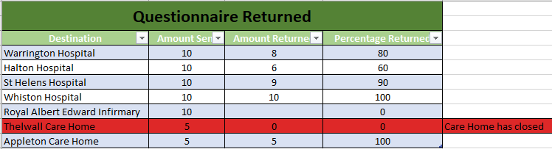

As you can see in this first table about how many returned questionnaires I would receive back. I stated earlier sixty had been sent out to different hospitals and care homes, in the first column you can see the names of the medical facilities that I posted them out to, the second column is the amount I sent to each one, then you will see what I have received back to-date, and the final column is the percentage of questionnaires that were returned, for a total of seventy percent (of possible returns the care home that closed down has not been included in the figures). This data was then automatically place into a graph to give a clear visual representation.

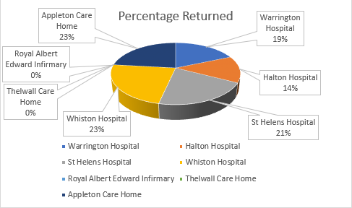

For the questionnaires answers I did the same thing I entered the information into a table of how they answered the yes and no question and again produced a visual representation this time using a bar chart.

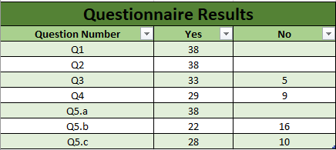

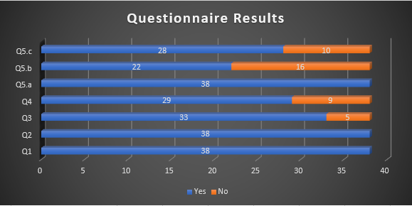

**Questionnaire Summary**

Looking at the yes or no portion of the questionnaire it is clear to see from the data above that all the medical professionals that answered the questions believe that the mental health and stability of a patient is part of the job role and that the right to say goodbye to loved ones in a suitable way is a massive part of that.

What we can also see from question four is that seventy seven percent believe that a sensory solution, like the Sensory Virtual Reality System, would be better for patients’ mental health.

Even with the question of other areas of use turned up interesting data, that even though the majority thought it was a good idea for mental health appointment it was extremely close with fifty six percent for it and forty-four against. The biggest thing to take note of is that everyone in this questionnaire agreed it would be an advantage for doctors communicating with patients especially for diagnosis when it can’t be in person.

There was a final section on the questionnaire in which they could add their own comments, most of the comments were positive for the system some showed concern over cost or if it’s possible to have the sensation of touch, but the main response was that they couldn’t see a system like this being brought in anytime soon as it is not believed that the NHS or government see a problem with the current situation.

## Data from Direct from Government and Hospitals

One of the first thing I did after deciding what my research would be about was workout what I would need and from who. I quickly realised I’d need fact and figures to do with Covid-19 deaths. I sent an email to the government department that deals with Covid-19 daily deaths figures through the email address, ‘*england.covid19dailydeaths@nhs.net’.* I explained who I am and what I was doing, and asked if they could answer four questions for me:

1. How many patients died in hospital after visitations were stopped?
2. What date where the iPads introduced to help with this?
3. How many iPads were issued?
4. Text

   Description automatically generatedHow many patients passed without a final communication to friends or family?

This is the response I received, as this clearly wasn’t of any help, I was advised to approach the NHS Trusts directly for these figures explaining again the reason for my contact and adding the further statement to try to ensure some figures “*Surely because of the mental health of patients this figure must have been recorded.”*

The response I got here states everyone had access to visitor and if they didn’t feel safe to enter the hospital, they had access to the iPad to communicate to loved ones.

Unfortunately, this contradicts my other research in which the BBC reported about thirty tablets only being spread across Birmingham on the 6th of April 2020 a fortnight after visitation was stopped there. (BBCNews, 2020)

According to the DEESIDE.COM it wasn’t until nearly the end of April, the 24th of April 2020, that *‘365 iPads are expected to be delivered to care homes and hospital wards next week as part of an innovative scheme being launched by the North Wales Regional Partnership Board. Further devices are due to arrive soon after.’* That is well over a month after visitors were told not to go to hospitals. (DEESIDE.COM, 2020)

The point they make on visitors being allowed to attend is a difficult one as the NHS and government guidance has been updated regularly to keep everyone informed. Yet there is a contradiction with what was being said.

(.southportandormskirk.nhs.uk, 2020)

Here you can see a screenshot from Southport NHS website asking people to stay away if you have or any family members have Covid-19, they do add other than in exceptional circumstances, but I believe reading this is where most people will have felt confused and unsure of what to do.

The biggest factor in me find this reply to lacking of the full truth in the matter, the Health Secretary Matt Hancock was on the daily up-date about the pandemic on the 15th of April 2020, stating that “Close family members will be able to see dying relatives to say goodbye under new coronavirus guidelines” (BBCNews, 2020) that’s three weeks after the visitor restrictions were in place. The is a link here for you to go and watch the clip <https://www.bbc.co.uk/news/uk-52299590.amp> its 48 seconds long but shows the contradiction clearly.

If I have been able to prove the contradiction to the email it means I have to disregard the email from my findings and the source can no longer be trusted for any information, this is one of the problems of not being sponsored by the NHS or the government when you need this type of question answered.

# 

# Time/Breakdown Schedule

|  |  |  |
| --- | --- | --- |
| **Week Commencing** | **Target** | **Completed (Y/N)** |
| October 18, 2021 | Research remote working | Y |
| October 25, 2021 | Research and choose theme, Context within theme, Choose topic, Hypothesis | Y |
| November 1, 2021 | Action Plan/Gantt chart, Basic research on methodologies | Y |
| November 8, 2021 | Start Proposal, Palliative care/end-of-life care | Y |
| November 15, 2021 | Current Situation | Y |
| November 22, 2021 | Email NHS, Reply From NHS, Virtual Reality in NHS | Y |
| November 29, 2021 | Research reports, Sensory Virtual Reality Tech | Y |
| December 6, 2021 |  | Y |
| December 13, 2021 | What questions can/need to be asked, What factors need to be considered, Write up proposal report and present PowerPoint | Y |
| December 20, 2021 |  |  |
| December 27, 2021 |  |  |
| January 3, 2022 | Start Research Report Paper, Justification | Y |
| January 10, 2022 | Literature Review | Y |
| January 17, 2022 | Limitations of the Study, Research Methods | Y |
| January 24, 2022 | Research Methods | Y |
| January 31, 2022 | Methodologies | Y |
| February 7, 2022 | Qualitative and Quantitative Research, | Y |
| February 14, 2022 | Primary and Secondary Research | Y |
| February 21, 2022 | Send Questionnaires, Interviews NHS staff | Y |
| February 28, 2022 |  |  |
| March 7, 2022 |  |  |
| March 14, 2022 |  |  |
| March 21, 2022 | Compile questionnaire replies, write up and compile all results | Y |
| March 28, 2022 | Make Graphs in Excel, Summary of Results | Y |
| April 4, 2022 | Ethics, Sensory Virtual Reality System Technology | Y |
| April 11, 2022 |  |  |
| April 18, 2022 |  |  |
| April 25, 2022 | Cost | Y |
| May 2, 2022 | Future Innovations | Y |
| May 9, 2022 | Critical Evaluation | Y |
| May 16, 2022 |  |  |
| May 23, 2022 | Prepare PowerPoint of Report Conclusion | Y |
| May 30, 2022 |  |  |
| June 6, 2022 | Present PowerPoint | Y |

For an in-depth break, down of how long each section took to complete please see the accompanying Gannt charts, you will notice there are two, Predicted Time Scale and Actual Time Scale. This is due to a false start at the beginning of the research project. I was originally going to research remote working within a call centre environment, but quickly realised that the subject had been overly done due to the Covid-19 pandemic. Therefore I quickly reassessed and opted for a subject I believed to be of more interest.

# Ethics

One of the biggest questions we have today is, “is it ethical?” this is by no means a simple question to answer as everybody interprets ethics differently, but when it comes to health care in the UK, we don’t have a Hippocratic Oath like America, we have General Medical Council (GMC) and they have laid out the good medical practice. The GMC looks after the supervision of the conduct of the medical profession, and they publish advice to doctors on the standards expected in the “Good Medical Practice”. The GMC is broken in to four main domains, Domain 1. Knowledge, skills and performance, Domain 2. Safety and quality, Domain 3. Communication, partnership and teamwork and Domain 4. Maintaining trust. I’m only going to talk about the points I believe are relevant to the use of a sensory virtual reality system by patients and medical professionals.

**Domain 1. Knowledge, skills, and performance**

* **Make the care of your patients your first concern.**
* **Provide a good standard of practice and care**.

Would it be considered as making your patient your first concern if you are using the SVR to give them a serious diagnosis as the patient could be on the restricted ward or even at home alone, furthermore would this be considered a good standard of care?

With doing my research I believe it is always the best practice and police to see patients face-to-face for any form of diagnosis, that being said when it is not allowed, I believe an SVR is superior solution to anything that we currently have in place, the phone can feel cold and disconnected and you can’t see a patients reaction to the news you are giving so there for you could miss something, the iPad is a step up as now you can see the patient but again there is no real human interaction, leaving patients feeling alone. The sensory virtual reality system will not only allow both parties to see each other but with the glove it will give the perception of touch, for example after a diagnosis just a squeeze of the hand can let the patient know you’re there for them, there not alone.

**Domain 3. Communication, partnership, and teamwork**

* **Communicate effectively.**

In this section to communicate effectively to me would mean that if the medical professional is using SVR then they need to make sure whoever they are going to be communicating to has the system as well otherwise you are back to the iPad situation above. Then the other side to the communication issue would be internet connection is the bandwidth fast enough if wireless is there a strong enough signal, again this is not just at hospitals or doctors’ offices this would also need to be look at from the patients’ homes.

**Domain 4. Maintaining trust**

* **Show respect for patients.**
* **Treat patients as individuals and respect their dignity.**
* **Treat patients politely and considerately.**
* **Respect patients' right to confidentiality.**

This domain is all on trust, trust is earned, so for me it’s on the doctors, nurses and on the government to build the trust up with patients by being completely honest about the system and if a patient is happy or comfortable using a new system that they don’t know, don’t push it give them a trial call to family or a friend so they can understand the technology better. The biggest part for me is the word dignity, is there any dignity is giving someone a life changing serious diagnosis in any other way than face-to-face?

(Council, 2021)

This flow chart was issued by the General Medical Council (GMC) to help doctors apply their ethical guidance to manage patient safety risks and to decide when it’s generally safe to treat patients remotely.

# Sensory Virtual Reality System Technology

The question here is a simple one does the technology exists for this system to come to fruition? The easy answer is yes, all the hardware is already out there through different companies being sold, but nobody has put it all together in one system yet. Even crucial parts of the software like realistic avatars (image to represent a particular person in the real world) are being prototyped.

## Headset

virtual reality headset is a head-mounted device that allows the users see the virtual reality world. Virtual reality headsets are most commonly used for gaming, but as I have written about above, they have now branched into other areas such as training surgeons through simulated operations and training doctors to be more empathetic to patients. In basic terms they are built up of components like, a stereoscopic head-mounted display which provides a separate image for each eye, giving the sensation of depth and the 3D effect, head-motion-tracking sensors system, which is designed to follow your head movements, and stereo sound to complete the sensation and feeling that your area there. Some VR headsets also have eye-tracking sensors which is important for the realistic avatars. The most popular model of virtual reality head set on the market currently is Oculus Quest 2, this is according to cnet tech. The Oculus is a part of the Facebook umbrella group, which means it will be compatible will most if not all of the other hardware needed.

## Smell

A company called Feelreal have made a sensory mask which is a scent generator containing nine individual aroma capsules that magnetically connect to the bottom of a VR mask. They state on their website that their technology can simulates tactile sensations to immerse you even deeper into the experience making it feel more real. This technology also Connects to any VR headset via Bluetooth or Wi-Fi without any wires and complicated setups, which is great as the simpler the system the better but if a design could be done with it integrated into the mask meaning there was less for elderly or end-of-life patients to do this would be a big step forward.

## Touch – Glove

HaptX have made a glove using their technology that displaces your skin the same way a real object would. With 133 points of tactile feedback per hand it makes for a level of realism that other devices can’t match. HaptX uses microfluidic skin to provide the feeling of true-contact, tactile actuators are used to displace the skin up to 2mm to apply physical pressure, replicating the sensation of real objects. The system also allows for multi-user networking, which makes it perfect for the purpose we are after as it will allow the sensation of touch from one user to another like a family member at home, holding the hand of their loved one in hospital.

## Realistic Avatars

We have all seen the characters in games and thought that’s good but not believably real, now there is a company who has photorealistic avatars, and they no longer need face tracking cameras in the prototype stage and its Facebook. Instead of using multiple cameras to map and track the face they are using a neural network that uses eye-tracking data and microphone audio to infer the user’s facial expression. Researchers found that the network can even pick up on audio cues for slight actions like wetting your lips. It’s noted that for the system to pick up such cues would require the headset to have a high-quality microphone. The system is still in the prototype stages and therefor still has problems to work out like how to generate the avatar in the first instance. David Heaney tested this system in March 2019 and signs off the article with this statement *“The ability to see photorealistic representations of others in true scale, fully tracked from real motion, with the ability to make eye contact, could fundamentally change the need for face-to-face interaction.”* (HEANEY, 2020)

# Cost

A virtual reality system for the hospital would not be a cheap system to put in place, but nor should it be, it should be a system that can be built upon and added for years to come not a one-off expense to then be forgotten about. there are three main options, low, medium, and high budget experiences.

**Low Budget**

the low budget option is around the twenty-thousand-pound mark to build and set up, short encounters on mobile devices, using 2D resources in a 3D environment and viewed with Google Cardboard, Google Daydream or Samsung Gear VR. Considering what we would be wanting to achieve I don’t believe this option should even be given a consideration.

**Medium Budget**

This option is more expensive at around eighty-thousand-pounds, and again with short experiences with Google Cardboard, Google Daydream or Samsung Gear VR I don’t believe it will offer the experience and quality that is needed even with more scripting, spatial audio and interactivity, character design, especially as the character design we are going for is a photorealistic representation of the user.

**High-End Budget**

Scripted experiences with game-like production for high-end headsets such as HTC Vive and Oculus in which the user can explore. As this is the most expensive option it does cost upwards of one hundred and fifty thousand pounds.

Funding for a Sensory Virtual Reality System like this doesn’t have to be cover by the taxpayer alone there are a couple of proven routes that can be taken. The first is to wait and allow the tech companies out there to build this type of system for, most likely, the gaming industry and then purchase the units in bulk direct from the companies and see if some form of deal can be done over data collection and software due to the nature of its use. The second avenue to be considered is to have the government set up a competition just as they did with the 5G networks tech.

As you can see from this screenshot I took from the government own website, they gave this press release of a thirty-million-pound competition. Therefor a precedent has been set, by no means would the prize money be nearly as high. But by using a competition format you will bring out the competitive nature from the tech companies, and even get companies involved that you never even though of giving more ideas, more rivalries, and more ingenuity. In a competition format you give the initial idea of what you like, but these companies could come up with thing you haven’t even considered making the system vastly improved and even offer a superior immersive experience.

# Future Innovations

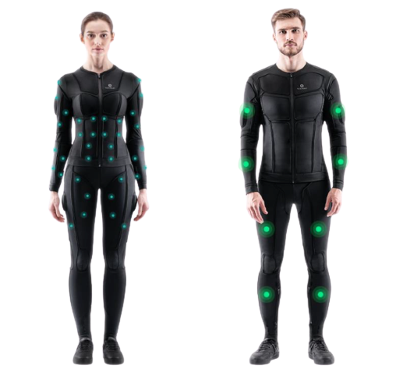Future innovations on this research a difficult to see as this research itself is for a future innovation, but it would be amiss if I didn’t mention innovations within the VR world as these could be the future for the Sensory Virtual Reality System. The full body VR suits is one of these possible future addition to this system. As with all the other hardware spoken about in this report full body VR suits are already on the market and according to linuxhint.com the Tesla Suit is the best currently available. The tesla suit allows you to feel and interact with any object within the VR system. These VR suits are currently being used to aid the training of athletes and patients in need of rehabilitation by transmitting sensations to the body through neuromuscular electrical stimulation, it gives very mild electrical stimulus.

(U, 2020)

This image shows the Teslasuit and the two differ placement of sensors within it, the sensors match in both suits.

There is currently no suit that can simulate the pressure on the like from that of a hug and this would mean a tightening of the suit across those areas, or air pressure being built up in the affected areas of the suit. This sort of process needless to say, would need to be done in a safe manner, so not to cause the user any harm or discomfort.

I think one of the most advanced innovations has already begun in headset-less VR. Japanese engineers have built a system that allows the user to experience without the need of wearing a headset. “*The virtual reality “Space Ride” creates a sensation that users are flying through the air inside the giant glass ball.”* (Kumar, 2017) The ride is a cross between the theme park and an IMAX cinema, there are elevated chairs that swivel in front of a semi-spherical screen which consumes their field of vision, which shows the users images coming closer to them physically on the screen which gives a completely different feel from the normal flat screen display. The author Pranjal Kumar, states as there sign off from this article “*The development of this technology clearly suggests that in future we might be able to view all things in VR without using any kind of the headset*.” (Kumar, 2017) This was in 2017 and I have not been able to find anything that suggest we have moved on any further from this ride.

All this advancement would be great but what I see as the future is this system being rolled out in a way that every isolation ward has enough systems that each patient can use them, and instead of loaning out systems or requiring families to them a room be set up in the hospital near an entrance (as visitors aren’t allowed in this won’t compromise anyone).

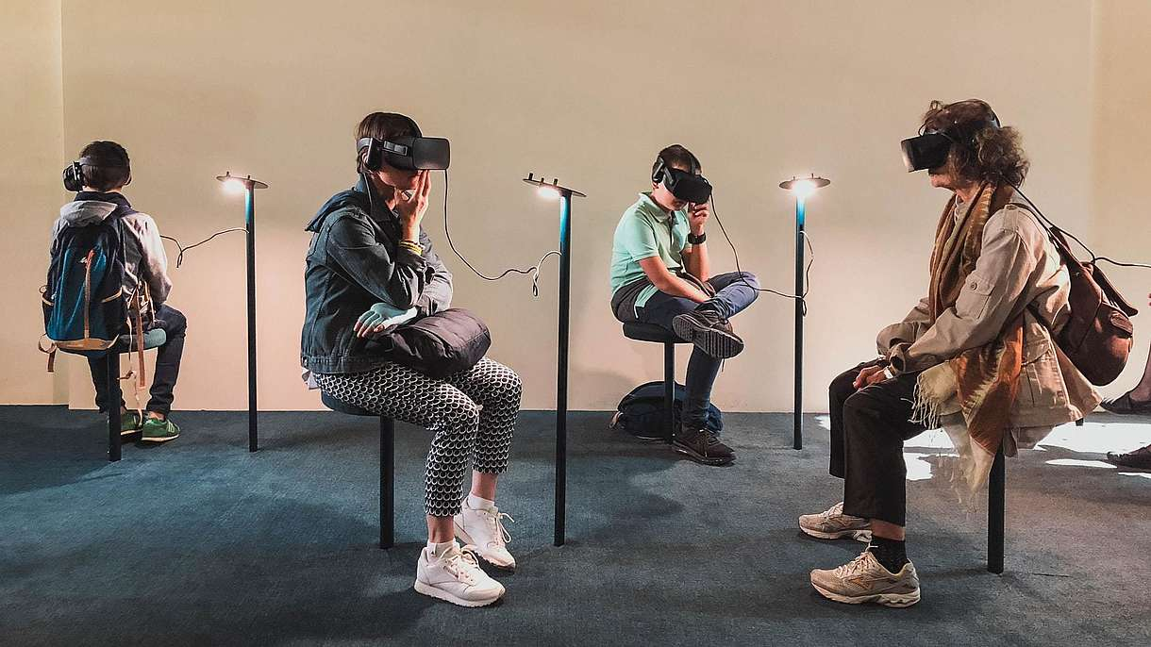 (Image:Lucrezia-Carnelos, 2020)

The room can be as simple set up as in the image with the only real difference being the inclusion of the sensory glove and with this simple set up it also meant in times of a pandemic the areas can be separated from each other with Perspex’s or something else.

# Critical Evaluation

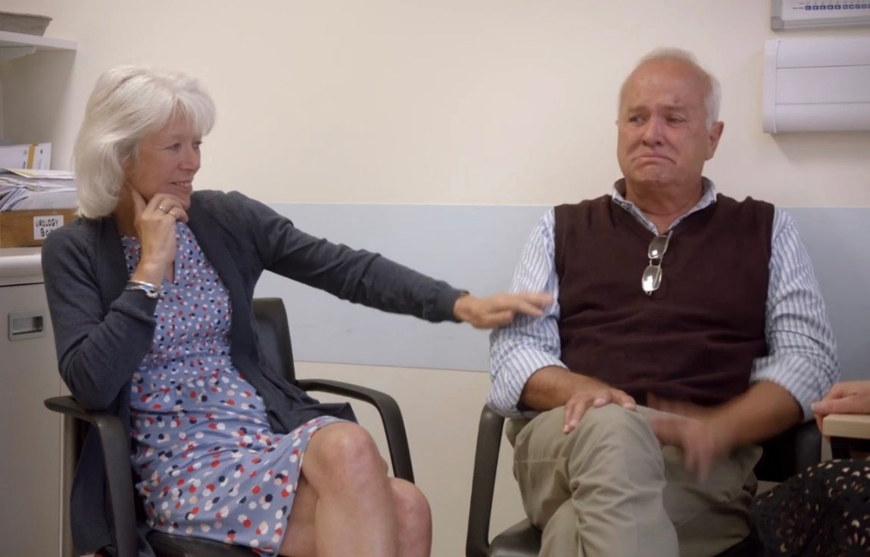To evaluate this report, we have to go back to the beginning and look at the current situation but this time I’d like to put a face to it.

(Cancer-Research-UK, 2019)

The gentleman in these pictures is called David and he is just being told he has prostate cancer; you can see how scared he is in his face. His life has been completely changed with the uncertainty and fear of not knowing.

(Cancer-Research-UK, 2019)

With one simple act the doctor reacted out and touched his arm to comfort and reassure him.

This simple acted can never be replaced by technology, but there must be a place between face-to-face and the cold feeling of a video chat on and iPad or phone. As humans in times of pain and hardship we need the comfort and support that a simple reassuring touch can give.

As you can see from all the data gathered through interviews and questionnaires from medical staff and data requests form the NHS and government departments, a Sensory Virtual Reality System would over all be positively received by the medical professionals who would be using it, even specifying particular areas they believe it would a real asset, I set out to see if it would benefit patients in palliative and end of life care and they agreed but also added that it would be extremely useful for doctors speaking with patients (especially when having to give bad or possible distressing news). Which was one of the suggested areas in the questionnaire. But the majority of data collected pointed to the same conclusion, that the medical staff have no faith in a system like this being implemented anytime soon by the NHS or the government, this is due to the fact that they believe neither party can see or will admit to the sort comings of the current iPad system especially throughout the pandemic period when it was rolled out to combat the visitor ban.

The Sensory Virtual Reality system is by no-way without its flaws and draws back such as the cost to run this system, how do you ensure both users have the same equipment? What sort of internet speed would be needed to run them? And many other questions that can only be answered with funded research, and that research being backed by the government or the NHS. These concerns were echoed in the interviews with the medical professionals, but it was also stated it’s a good idea especially have the touch ability and would give a great starting point for future innovation to bridge this massive gap in health care communication. With the overall feeling that for improvement to take place the NHS and government need to admit there is a problem with the current situation of remote communication.

# Record of Sources and References

|  |
| --- |
| Books |
| Giuliana Guazzaroni – Virtual and Augmented Reality in Mental Health Treatment – 2018 - Publisher: IGI Global |
| Clive Langman - Introduction to Vocational Rehabilitation Policies, Practices and Skills – 2012 - Publisher: Taylor & Francis |
| Frank Biocca - Communication in the Age of Virtual Reality – 2013 - Publisher: Taylor & Francis |
| Editors: Halimah Badioze Zaman, Ingela Nyström, Maria Petrou, Patrick Olivier, Peter Robinson, Sergio Velastin, Timothy K. Shih - Visual Informatics: Sustaining Research and Innovations – 2011 - Publisher: Springer. |
| Leland Graham, Isabelle McCoy - How to Write a Great Research Paper: A Step-By-Step Handbook – Publisher: Incentive Publications, Incorporated - 2014 |
| Editor: Modern Language Association of America - MLA Handbook for Writers of Research Papers - Edition 7 - Publisher: Modern Language Association of America - 2009 |
| Higher Nationals in Computing Core Textbook Level 4 HNC and Level 5 HND - Publisher: Pearson - 2018 |
|  |
|  |

|  |
| --- |
| Journals, Research Papers and PDF’s |
| Nick Peres - Head of Technologies R+D PhD Transtechnology Researcher - Virtual Reality in healthcare and potential application to NHS library services |
| Justyna Mazurek, Paweł Kiper, Błażej Cieślik, Sebastian Rutkowski - Virtual Reality in Medicine: A Brief Overview and Future Research Directions – 2019 |
| Justyna Mazurek, Paweł Kiper, Błażej Cieślik, Sebastian Rutkowski - Virtual reality in medicine: A brief overview and future research directions – ResearchGate - 2019 |
|  |
|  |
|  |
|  |
|  |
|  |

|  |
| --- |
| Website & others |
| https://www.marxentlabs.com/what-is-virtual-reality/ |
| https://www.bbc.com/academy-guides/virtual-reality-production-where-do-i-start#howmuchdoesvrcost? |
| https://hbr.org/2019/10/research-how-virtual-reality-can-help-train-surgeons |
| https://www.nicole-brown.co.uk/epistemology/ |
| https://www.nicole-brown.co.uk/methodology-and-methods-what-are-they/ |
| https://www.youtube.com/watch?app=desktop&v=MljuWE_J3Vw |
| https://www.c-care.ca/blog/home-care/what-a-palliative-nurse-does/ |
| https://www.gmc-uk.org/ethical-guidance/ethical-hub/remote-consultations |
| https://feelreal.com/ |
| https://medicalfuturist.com/5-ways-medical-vr-is-changing-healthcare/ |
| https://www.therotherhamft.nhs.uk/News/Current/Changes_to_visitor_restrictions_from_Monday_23_March/ |
| https://haptx.com/ |
| https://patient.info/doctor/ideals-and-the-hippocratic-oath |
| https://www.health.harvard.edu/staying-healthy/telehealth-the-advantages-and-disadvantages |
| https://uploadvr.com/frl-codec-avatars-without-face-tracking/ |
| https://www.researchgate.net/publication/320247900_Knowledge_Management_Methodology_Developing_a_Phenomenalogical_Middle-range_Thinking_Approach_for_Knowledge_Management_Research |
| https://uk.indeed.com/career-advice/finding-a-job/remote-work |
| https://www.polygon.com/2016/1/15/10772026/virtual-reality-guide-oculus-google-cardboard-gear-vr |
| https://www.pocket-lint.com/ar-vr/news/oculus/133835-forget-head-tracking-on-oculus-rift-fove-vr-headset-can-track-your-eyes |
| https://www.england.nhs.uk/nursingmidwifery/shared-governance-and-collective-leadership/nursing-covid-19-catalogue-of-change/visiting-during-the-covid-19-pandemic/ |
| https://www.oculus.com/quest-2/ |
| https://www.cnet.com/tech/gaming/best-vr-headsets/ |
| https://teslasuit.io/ |
| https://www.youtube.com/watch?app=desktop&v=Yp9TRLbr7LI |
| https://linuxhint.com/best_vr_bodysuits/ |
| https://www.gov.uk/government/news/new-30-million-competition-to-make-uk-a-pioneer-in-building-5g-networks |
| https://warwick.ac.uk/fac/soc/ces/research/current/socialtheory/maps/ology/ |
| https://www.yourdictionary.com/avatar |
| https://www.yourdictionary.com/sensory |
| https://www.bbc.co.uk/news/uk-52299590.amp |
| https://www.techleer.com/articles/205-japanese-engineers-develop-headset-less-virtual-reality-system/ |
| https://www.ne-mo.org/news/article/nemo/nemo-report-on-digitisation-and-copyright-challenges-of-making-museum-collections-accessible-online.html |

# Tutorial Meetings:

|  |  |
| --- | --- |
| Date of meeting: | 20/10/2021 |
| Progress made  since last  meeting | N/A |
| Student targets/  actions for next  meeting | 1.) Research remote working |
|  | 2.) Research and choose theme,  Context within theme,  Choose topic,  Hypothesis |
|  | 3.) Action Plan/Gantt chart |
| Signed Tutor: Mark Evans | Student: Mathew Barber |

|  |  |
| --- | --- |
| Date of meeting: | 04/11/2021 |
| Progress made  since last  meeting | Research remote working  Research and choose theme  Context within theme  Choose topic  Hypothesis  Action Plan/Gantt chart |
| Student targets/  actions for next  meeting | 1.) Start Proposal |
|  | 2.) Basic research on methodologies |
|  | 3.) Palliative care/end-of-life care  Current Situation |
| Signed Tutor: Mark Evans | Student: Mathew Barber |

|  |  |
| --- | --- |
| Date of meeting: | 22/11/2021 |
| Progress made  since last  meeting | Start Proposal  Basic research on methodologies  Palliative care/end-of-life care  Current Situation |
| Student targets/  actions for next  meeting | 1.) Email NHS |
|  | 2.) Virtual Reality in NHS  Sensory Virtual Reality Tech  What questions can/need to be asked  What factors need to be considered |
|  | 3.) Write up proposal Report and PowerPoint |
| Signed Tutor: Mark Evans | Student: Mathew Barber |

|  |  |
| --- | --- |
| Date of meeting: | 17/12/2021 |
| Progress made  since last  meeting | Write up proposal Report and PowerPoint |
| Student targets/  actions for next  meeting | 1.) Start Research Report Paper |
|  | 2.) |
|  | 3.) |
| Signed Tutor: Mark Evans | Student: Mathew Barber |

|  |  |
| --- | --- |
| Date of meeting: | 04/01/2022 |
| Progress made  since last  meeting | Start Research Report Paper |
| Student targets/  actions for next  meeting | 1.) Justification  Literature Review  Limitations of the Study |
|  | 2.) Research Methods |
|  | 3.) Qualitative and Quantitative Research  Primary and Secondary Research |
| Signed Tutor: Mark Evans | Student: Mathew Barber |

|  |  |
| --- | --- |
| Date of meeting: | 18/02/2022 |
| Progress made  since last  meeting | 1.) Justification  Literature Review  Limitations of the Study  2.) Research Methods  3.) Qualitative and Quantitative Research  Primary and Secondary Research |
| Student targets/  actions for next  meeting | 1.) Send Out Questionnaires |
|  | 2.) Interviews with NHS Staff  Interviews with NHS Staff |
|  | 3.) Compile Questionnaire Replies  Write Up Results  Summary of Results |
| Signed Tutor: Mark Evans | Student: Mathew Barber |

|  |  |
| --- | --- |
| Date of meeting: | 04/04/2022 |
| Progress made  since last  meeting | Send Out Questionnaires  Interviews with NHS Staff  Interviews with NHS Staff  Compile Questionnaire Replies, Write Up Results, Summary of Results |
| Student targets/  actions for next  meeting | 1.) Compile Data Collected from Government  Compile Data Collected Direct From NHS |
|  | 2.) Ethics  Sensory Virtual Reality System Technology |
|  | 3.) Future Innovations  Critical Evaluation |
| Signed Tutor: Mark Evans | Student: Mathew Barber |

|  |  |
| --- | --- |
| Date of meeting: | 23/05/2022 |
| Progress made  since last  meeting | Compile Data Collected from Government, Compile Data Collected Direct From NHS, Future Innovations, Critical Evaluation |
| Student targets/  actions for next  meeting | 1.) Prepare PowerPoint of Report Conclusion |
|  | 2.) |
|  | 3.) |
| Signed Tutor: Mark Evans | Student: Mathew Barber |

|  |  |
| --- | --- |
| Date of meeting: | 06/06/2022 |
| Progress made  since last  meeting | Prepare PowerPoint of Report Conclusion |
| Student targets/  actions for next  meeting | 1.) Present PowerPoint - Sign Off Sheet |
|  | 2.) |
|  | 3.) |
| Signed Tutor: Mark Evans | Student: Mathew Barber |

# Bibliography

.southportandormskirk.nhs.uk, 2020. *Coronavirus (Covid-19) restricts visiting at hospitals.* [Online]   
Available at: https://www.southportandormskirk.nhs.uk/coronavirus-covid-19-restricts-visiting-at-hospitals/  
[Accessed 13 10 2021].

Anon., n.d. s.l.:s.n.

Bardi, J., 2020. *What is Virtual Reality? [Definition and Examples].* [Online]   
Available at: https://www.marxentlabs.com/what-is-virtual-reality/  
[Accessed 08 10 2021].

BBC, 2021. *Virtual reality production: Where do I start?.* [Online]   
Available at: https://www.bbc.com/academy-guides/virtual-reality-production-where-do-i-start#howmuchdoesvrcost?  
[Accessed 10 10 2021].

BBCNews, 2020. *Coronavirus: Close family to be allowed to say goodbye to the dying.* [Online]   
Available at: https://www.bbc.co.uk/news/uk-52299590.amp  
[Accessed 23 10 2021].

BBCNews, 2020. *Coronavirus: Hospital iPads could be used 'to say goodbye'.* [Online]   
Available at: https://www.bbc.co.uk/news/uk-england-birmingham-52185204  
[Accessed 23 10 2021].

Blumstein, G., 2019. *Research: How Virtual Reality Can Help Train Surgeons.* [Online]   
Available at: https://hbr.org/2019/10/research-how-virtual-reality-can-help-train-surgeons  
[Accessed 08 10 2021].

Brown, D. N., 2021. *Epistemology.* [Online]   
Available at: https://www.nicole-brown.co.uk/epistemology/  
[Accessed 08 10 2021].

Brown, D. N., 2021. *Methodology and methods – what are they?.* [Online]   
Available at: https://www.nicole-brown.co.uk/methodology-and-methods-what-are-they/  
[Accessed 08 10 2021].

Cancer-Research-UK, 2019. *Thanks to research, this is David right now.* [Online]   
Available at: https://www.youtube.com/watch?app=desktop&v=MljuWE_J3Vw  
[Accessed 14 10 2021].

C-Care, 2017. *What Does A Palliative Care Nurse Do?.* [Online]   
Available at: https://www.c-care.ca/blog/home-care/what-a-palliative-nurse-does/  
[Accessed 30 09 2021].

Council, T. G. M., 2021. *Remote consultations.* [Online]   
Available at: https://www.gmc-uk.org/ethical-guidance/ethical-hub/remote-consultations  
[Accessed 09 10 2021].

DEESIDE.COM, 2020. *iPads being issued to North Wales hospitals and care homes to help people stay in touch with family and friends.* [Online]   
Available at: https://www.deeside.com/ipads-being-issued-to-north-wales-hospitals-and-care-homes-to-help-people-stay-in-touch-with-family-and-friends/  
[Accessed 23 10 2021].

Feelreal, 2018. *Feelreal Sensory Mask.* [Online]   
Available at: https://feelreal.com/  
[Accessed 09 10 2021].

Futurist, T. M., 2021. *5 Ways Medical Virtual Reality Is Already Changing Healthcare.* [Online]   
Available at: https://medicalfuturist.com/5-ways-medical-vr-is-changing-healthcare/  
[Accessed 08 10 2021].

Government, U., 2020. *Changes to visitor restrictions from Monday 23 March.* [Online]   
Available at: https://www.therotherhamft.nhs.uk/News/Current/Changes_to_visitor_restrictions_from_Monday_23_March/  
[Accessed 08 10 2021].

HaptX, 2021. *HAPTX GLOVES DK2.* [Online]   
Available at: https://haptx.com/  
[Accessed 09 10 2021].

Harding, D. M., 2015. *Ideals and the Hippocratic Oath.* [Online]   
Available at: https://patient.info/doctor/ideals-and-the-hippocratic-oath  
[Accessed 09 10 2021].

HarvardHealth, 2020. *Telehealth: The advantages and disadvantages.* [Online]   
Available at: https://www.health.harvard.edu/staying-healthy/telehealth-the-advantages-and-disadvantages  
[Accessed 30 09 2021].

HEANEY, D., 2020. *Facebook’s Prototype Photoreal Avatars No Longer Require Face Tracking.* [Online]   
Available at: https://uploadvr.com/frl-codec-avatars-without-face-tracking/  
[Accessed 09 10 2021].

Ibrahim, F., 2017. *Knowledge Management Methodology: Developing a Phenomenalogical Middle-range Thinking Approach for Knowledge Management Research.* [Online]   
Available at: https://www.researchgate.net/publication/320247900_Knowledge_Management_Methodology_Developing_a_Phenomenalogical_Middle-range_Thinking_Approach_for_Knowledge_Management_Research  
[Accessed 08 10 2021].

Image:Lucrezia-Carnelos, 2020. *NEMO report on digitisation and copyright.* [Online]   
Available at: https://www.ne-mo.org/news/article/nemo/nemo-report-on-digitisation-and-copyright-challenges-of-making-museum-collections-accessible-online.html  
[Accessed 30 10 2021].

Indeed, 2021. *What Is Remote Work?.* [Online]   
Available at: https://uk.indeed.com/career-advice/finding-a-job/remote-work  
[Accessed 30 09 2021].

Justyna Mazurek, P. K. B. C. S. R., 2019. *Virtual reality in medicine: A brief overview and future research directions.* [Online]   
Available at: https://www.researchgate.net/publication/333633423_Virtual_reality_in_medicine_A_brief_overview_and_future_research_directions  
[Accessed 23 10 2021].

Kuchera, B., 2016. *THE COMPLETE GUIDE TO VIRTUAL REALITY IN 2016.* [Online]   
Available at: https://www.polygon.com/2016/1/15/10772026/virtual-reality-guide-oculus-google-cardboard-gear-vr  
[Accessed 10 10 2021].

Kumar, P., 2017. *Japanese engineers develop headset-less Virtual reality system.* [Online]   
Available at: https://www.techleer.com/articles/205-japanese-engineers-develop-headset-less-virtual-reality-system/  
[Accessed 25 10 2021].

Miles, S., 2015. *Forget head tracking on Oculus Rift, Fove VR headset can track your eyes.* [Online]   
Available at: https://www.pocket-lint.com/ar-vr/news/oculus/133835-forget-head-tracking-on-oculus-rift-fove-vr-headset-can-track-your-eyes  
[Accessed 10 10 2021].

NHS, 2020. *Visiting during the COVID-19 pandemic.* [Online]   
Available at: https://www.england.nhs.uk/nursingmidwifery/shared-governance-and-collective-leadership/nursing-covid-19-catalogue-of-change/visiting-during-the-covid-19-pandemic/  
[Accessed 08 10 2021].

OCULAS, 2021. *QUEST 2.* [Online]   
Available at: https://www.oculus.com/quest-2/  
[Accessed 10 10 2021].

Pearson, 2018. *Higher Nationals in Computing.* Essex: Pearson.

Stein, S., 2021. *Best VR headsets to buy in 2021.* [Online]   
Available at: https://www.cnet.com/tech/gaming/best-vr-headsets/  
[Accessed 10 10 2021].

Teslasuit, 2021. *A breakthrough in human performance training.* [Online]   
Available at: https://teslasuit.io/  
[Accessed 14 10 2021].

TheGamer, 2021. *How Much You Can Feel In A VR Suit.* [Online]   
Available at: https://www.youtube.com/watch?app=desktop&v=Yp9TRLbr7LI  
[Accessed 14 10 2021].

U, S., 2020. *Best VR Bodysuits to Buy.* [Online]   
Available at: https://linuxhint.com/best_vr_bodysuits/  
[Accessed 15 10 2021].

Warman-MP, M., 2021. *New £30 million competition to make UK a pioneer in building 5G networks.* [Online]   
Available at: https://www.gov.uk/government/news/new-30-million-competition-to-make-uk-a-pioneer-in-building-5g-networks  
[Accessed 10 10 2021].

Warwick, U. o., 2017. *ontology.* [Online]   
Available at: https://warwick.ac.uk/fac/soc/ces/research/current/socialtheory/maps/ology/  
[Accessed 08 10 2021].

YOURDICTIONARY, 2021. *Avatar meaning.* [Online]   
Available at: https://www.yourdictionary.com/avatar  
[Accessed 09 10 2021].

YOURDICTIONARY, 2021. *Sensory meaning.* [Online]   
Available at: https://www.yourdictionary.com/sensory  
[Accessed 08 10 2021].